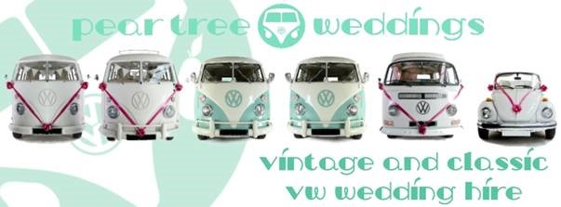
Travel Consent Form
Name of couple getting married
Date of wedding
Due to their age Morris, Wilson, Basil, Daphne, Bernie, Flossy, Wilma and Bruce are registered as classic cars, and are exempt from the current seatbelt laws that were introduced in 1965. This means any passengers travelling in our vehicles travel at their own risk.
We require any child under 18years, for insurance purposes, to have received full parental / legal guardian consent prior to travel in our vehicles. Children will also be required to be accompanied by a responsible adult whilst travelling in a Pear Tree Weddings vehicle.
I / We
(parents & guardians names)
give full consent for my child / children
Name |  |  | age
Name |  |  | age
Name |  |  | age
to travel unsecured within the vehicles supplied by Pear Tree Weddings. In the event of an accident, be it third party fault, or the fault of the chauffeur, we waiver our rights to pursue any claims that might arise from injury due to the unforeseen happening against the company known as Pear Tree Weddings, and all parties related to the business known as Pear Tree Weddings.
Children under the age of 3years old cannot travel in our VWs.
Signed
Print
Date
Children 3yrs- 18yrs will simply not be allowed in our VWs unless this form has been completed and returned to Pear Tree Weddings well in advance of the wedding.
Please complete this with a ‘real’ signature & return to :
Pear Tree Weddings, Pear Tree Cottage, 9 Showsley Road, Shutlanger, NN12 &RW

